Chapter 19, Problem 92.

Determine A_{v}, A_{i}, Z_{in}, and Z_{out} for the amplifier shown in Fig.19.131. Assume that

h_{ie} = 4 kΩ, h_{re} = 10⁻⁴

h_{fe} = 100, h_{oe} = 30 μ S

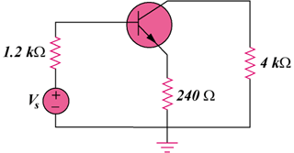
Figure 19.131
For Prob. 19.92.

